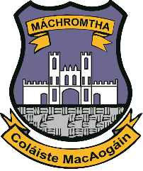
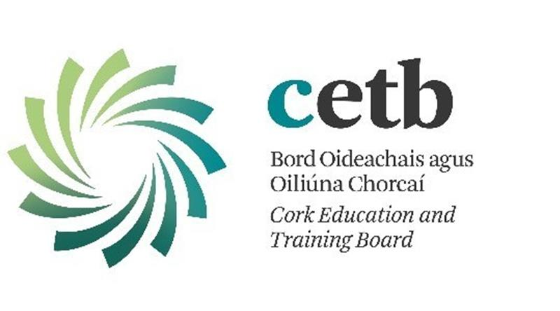

McEgan College is a constituent College of Cork Education and Training Board which makes it part of a large family or organisation that provides a pathway to education for a vast array of learners across Cork City and County.
Cork ETB Vision
Cork Education and Training Board is a driving force of education and training in Cork, providing high quality services which are innovative, responsive and inclusive. Through Cork ETB there is a pathway for every learner.
Mission
Cork Education and Training Board (CETB) plans, provides, supports and coordinates education, training and youth services in Cork which are recognised internationally as a model of excellence.
Guiding Principles
Cork ETB will always act in the best interests of learners. The following principles underpin our strategic thinking, planning, decision making and our everyday actions as we strive to deliver our services: Prioritising the needs of learners Being customer focused Acting with professional integrity Doing the right thing Treating people with dignity and respect Being fair, open and accountable Ensuring value for money Operating to the highest ethical, professional, moral and legal standards.
Cork ETB Values
Brave: We put our learners needs first and are not afraid to make the hard decisions required to deliver the best possible service.
Committed: We have a clear vision and purpose with which we are fully engaged and on which we are determined to deliver. Positive: We are optimistic and confident about our opportunities and challenges and believe we can make a positive difference to the lives of the people we serve.
Leading: We expect our people to be leaders – to have a clear vision, take the initiative, and to inspire and motivate learners and colleagues through their example.
Innovative: We are focused on constant improvement and being at the forefront of change and innovation in education and training.
Caring: We adopt an inclusive and respectful approach to our learners and staff and strive to ensure that each person using our services reaches his/her potential.
More information available on www.corketb.ie

