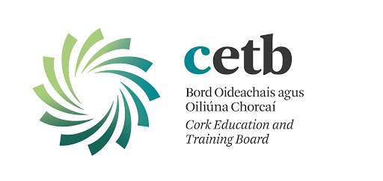
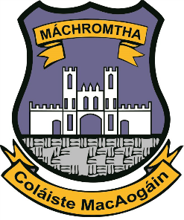
March 2021

Return to Learning Form

Please complete and email info.office@mcegan.ie before your child returns to school.

Child’s Name & Address: | School Name:
Parent/Guardian Name: | Principal Name:
Declaration:

I have no reason to believe that my child has infectious disease and I have followed all medical and public health guidance with respect to exclusion of my child from educational
facilities.

Signed ______________________________________ Date:_____________________

Please note that Cork ETB is collecting this data for the purposes of maintaining safety within schools in the light of the Covid-19 pandemic. The legal basis for collecting this data is based on vital public health interests and this data will be held securely in line with our retention policy. Cork ETB's Covid-19 Privacy Notice is available for review here: https://www.corketb.ie/wp-content/uploads/2020/06/CETB-Covid-19-Privacy-Notice.pdf

